Lab 9: Configuring Rack Awareness

Objective: To use the Ambari Web UI to configure rack awareness

[root@golden-node1 ~]# ls /etc/hadoop/conf

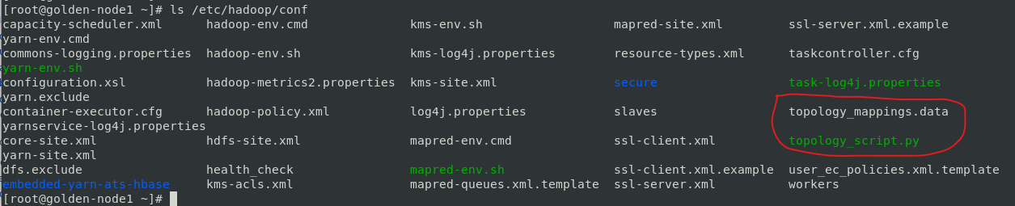

[root@golden-node1 ~]# cat /etc/hadoop/conf/topology_mappings.data

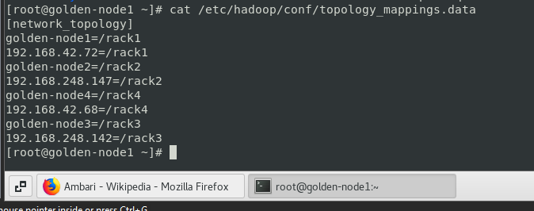

[root@golden-node1 ~]# su – hdfs

[hdfs@golden-node1 ~]$ hdfs fsck –racks

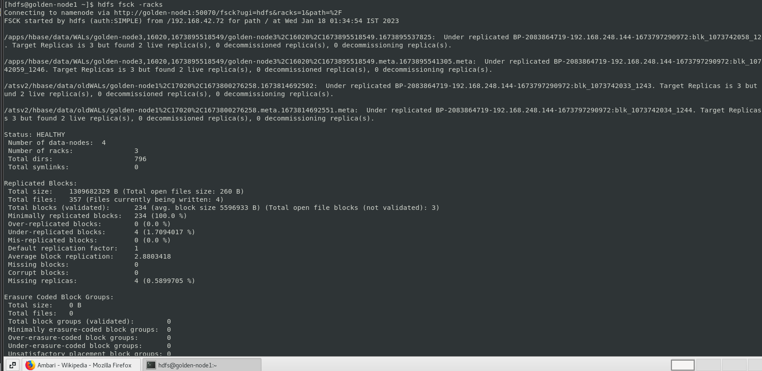

[hdfs@golden-node1 ~]$ hdfs dfsadmin –report

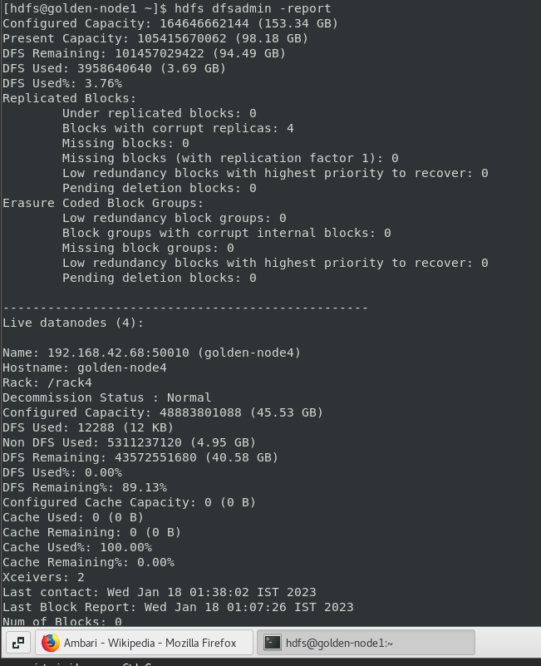

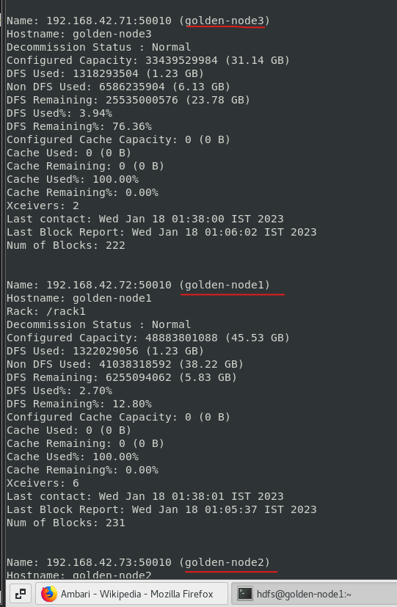

Configuring Rack Awareness

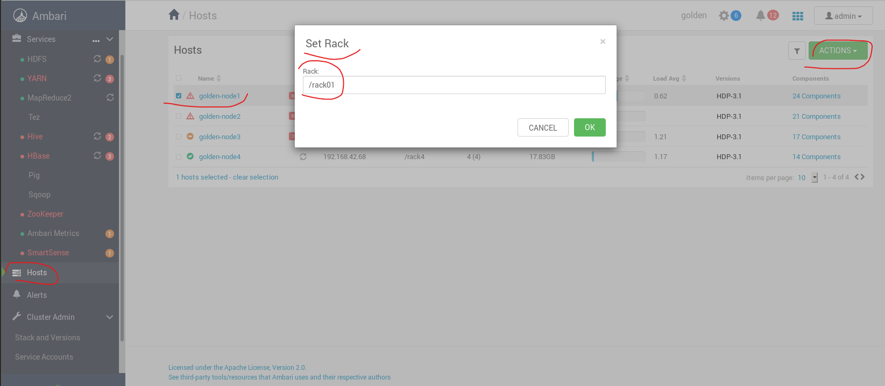

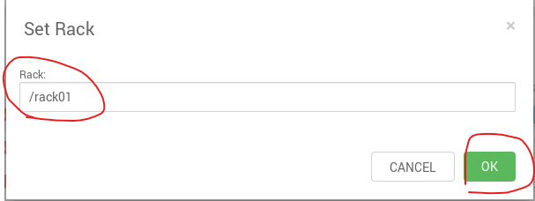

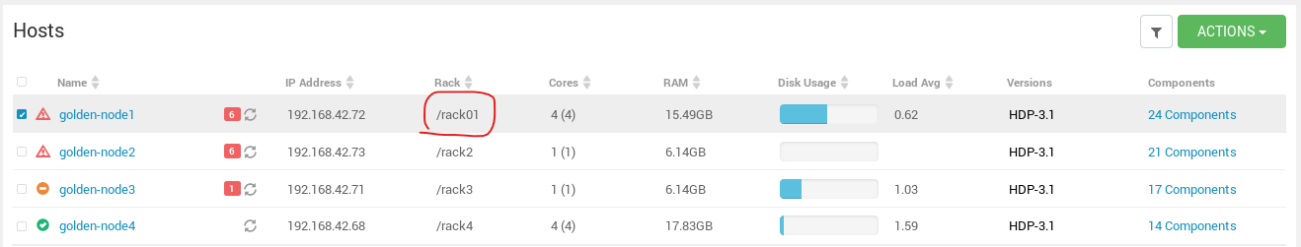

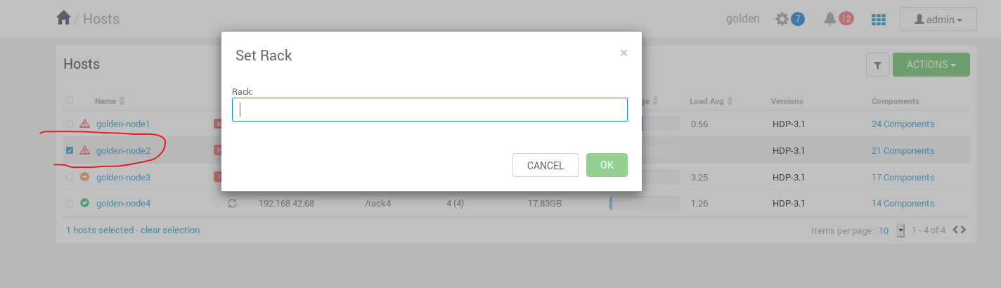

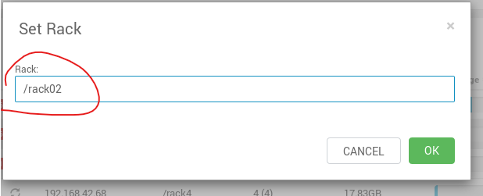

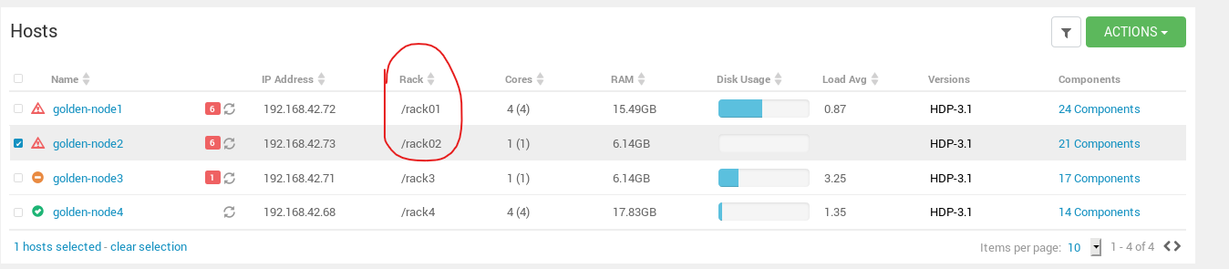

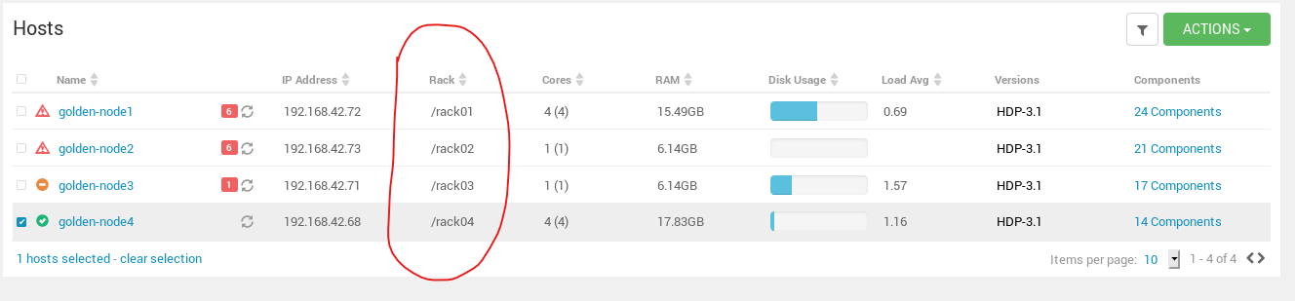

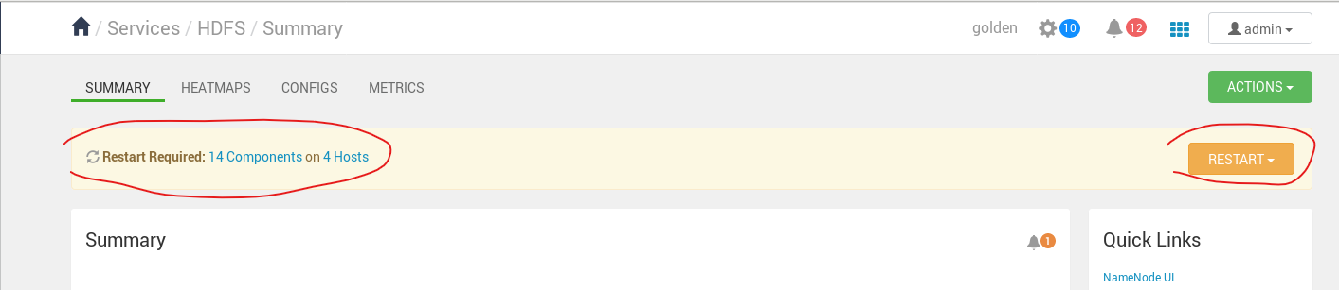

[hdfs@golden-node1 ~]$ cat /etc/hadoop/conf/topology_mappings.data

Before:

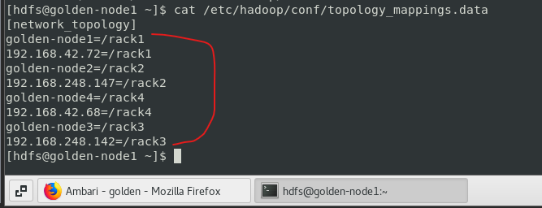

After:

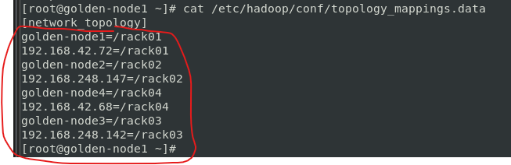

[hdfs@golden-node1 ~]$ hdfs fsck -racks

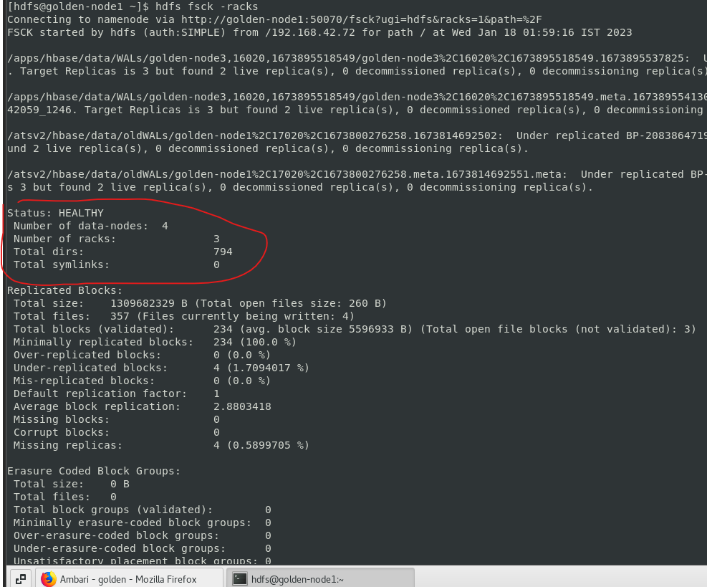

[hdfs@golden-node1 ~]$ hdfs dfsadmin –report

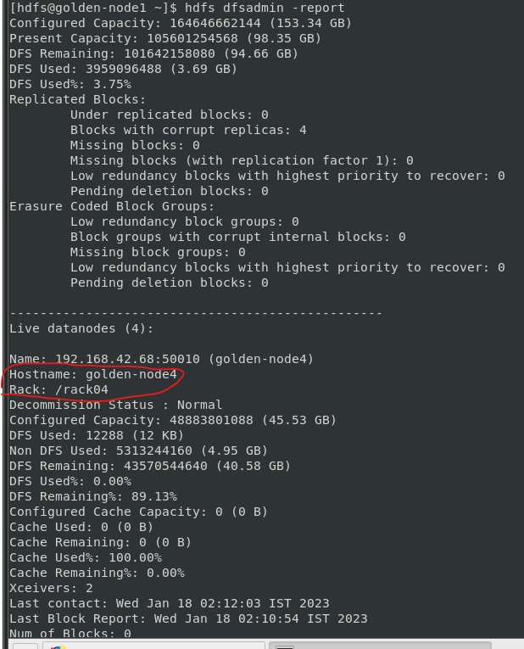

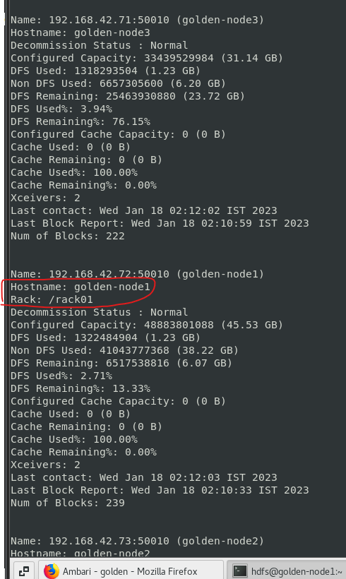

[hdfs@golden-node1 ~]$ exit